**Algorithm Implementation**. Implement the algorithms  
indicated for each **data set**. **20 points for the implemented algorithm**.  
1.      **[23,89, 7, 56, 44] –**Implement the Bubble Sort Algorithm for the Dataset and  
sort the data into **ascending order**.

Code:

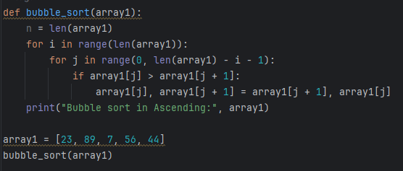

Output:  
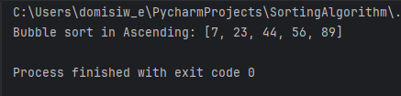

2.      **[12, 78, 91, 34, 62] –**Implement the  
Insertion Sort Algorithm for the Dataset and sort the data into **ascending  
order**.

Code:

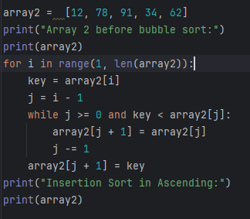

Output:  
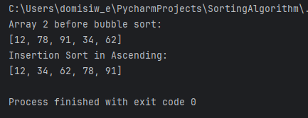

3.      **[5, 99, 48, 15, 67] –**Implement the  
Selection Sort Algorithm for the Dataset and sort the data into **descending  
order**.

Code:

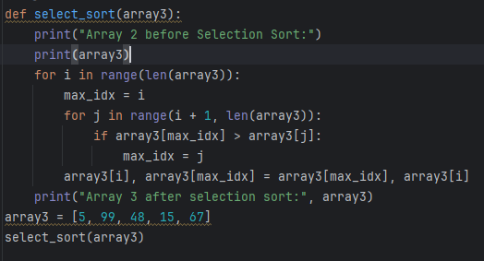

Output:  
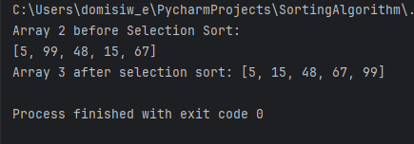

4.      **[38, 82, 25, 74, 13] –**Implement the  
Insertion Sort Algorithm for the Dataset and sort the data into **descending  
order.**  
Code:

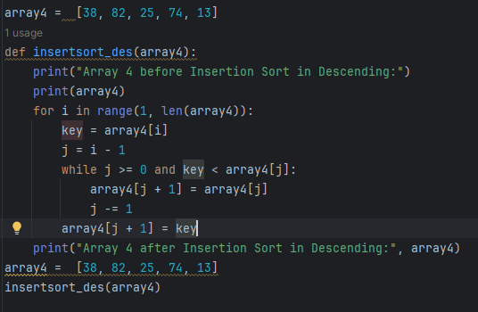

Output:

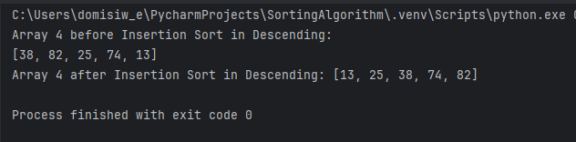  
  
5.      **Copy** all of the values from the  
second index and third index of the **previous datasets** into **one  
dataset.**After copying, sort the data into **ascending order** and **descending  
order** each order of the dataset is inserted into a separate list/array.

Code:

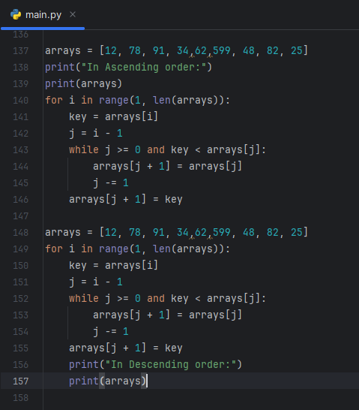

Output:

6.      Create a new list/array or values copying all of  
the values from **item number 1 to 4**. Implement the **Selection  
Sort Algorithm** and sort the data into **ascending order**.  
Code:

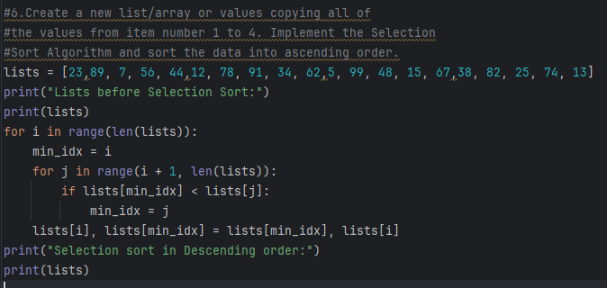

Output:

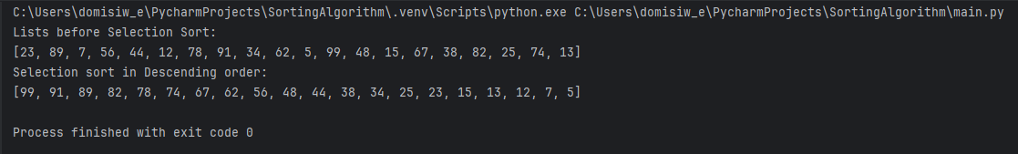  
  
7.      Print the **even and odd** values of the  
list/array created in **item number 6**.